Scripting

Joined on May 15th 2023
From then,

We have written some of the scripts for basic automation, Here are they

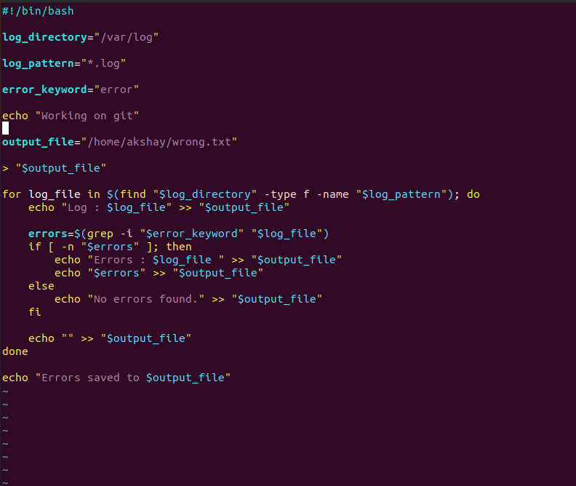

In this script, if the errors are found in the log files then they are noted and send that to an output file if errors are not presented then it gives no error

And later on this was the task given ,
We were told to Install some of the important software in our laptop

* Git
* Docker
* Amazon CLI
* Azure CLI
* Slack
* Pg Admin
* SQL workbench
* Visual code

And we was told to write a script to install all the software at one-go
and we came up with this script which is below
